// IF10

#include<iostream>

using namespace std;

int main()

{

setlocale(LC_ALL, "Ru");

int a, b, c = 0;

cin >> a >> b;

if (a != b)

{

c = a + b;

a = c;

b = c;

}

else

{

a = 0;

b = 0;

}

cout << a << endl << b;

}

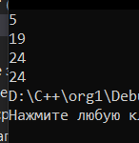 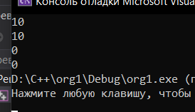

// IF12

#include<iostream>

using namespace std;

int main()

{

setlocale(LC_ALL, "Ru");

int a, b, c;

cin >> a >> b >> c;

if (a < b && a < c)

{

cout << a;

}

if (b < a && b < c)

{

cout << b;

}

if ( c < a && c < b)

{

cout << c;

}

}

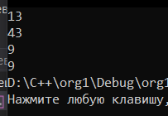 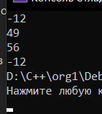

// IF14

#include<iostream>

using namespace std;

int main()

{

setlocale(LC_ALL, "Ru");

int a, b, c, mini = 0, maxi = 0;

cin >> a >> b >> c;

if (a < b && a < c)

{

mini = a;

}

if (b < a && b < c)

{

mini = b;

}

if ( c < a && c < b)

{

mini = c;

}

if (a > b && a > c)

{

maxi = a;

}

if (b > a && b > c)

{

maxi = b;

}

if (c > a && c > b)

{

maxi = c;

}

cout << mini << endl << maxi;

}

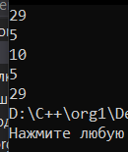 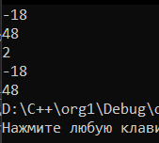

// IF16

#include<iostream>

using namespace std;

int main()

{

setlocale(LC_ALL, "Ru");

int a, b, c;

cin >> a >> b >> c;

if (a < b && b < c)

{

a *= 2;

b *= 2;

c *= 2;

}

else

{

a = -a;

b = -b;

c = -c;

}

cout << a << endl << b << endl << c;

}

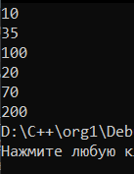 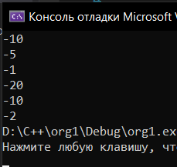

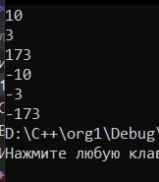

// IF18

#include<iostream>

using namespace std;

int main()

{

setlocale(LC_ALL, "Ru");

int a, b, c;

cin >> a >> b >> c;

if (a == b)

{

cout << 3;

}

if (b == c)

{

cout << 1;

}

if (a == c)

{

cout << 2;

}

}

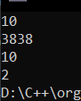 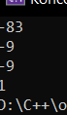

// IF20

#include<iostream>

#include<math.h>

using namespace std;

int main()

{

setlocale(LC_ALL, "Ru");

int a, b, c;

cin >> a >> b >> c;

if (fabs(a - b) > fabs(a - c))

{

cout << "C " << fabs(a - c) ;

}

if (fabs(a - b) < fabs(a - c))

{

cout << "B " << fabs(a - b);

}

if (fabs(a - b) == fabs(a - c))

{

cout << "Они одинаково удаленны от точки А на " << fabs(a - b);

}

}

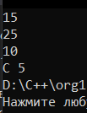 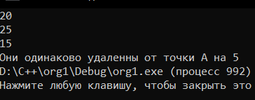

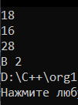

// IF22

#include<iostream>

using namespace std;

int main()

{

setlocale(LC_ALL, "Ru");

int x, y;

cin >> x >> y;

if (x > 0 && y > 0)

{

cout << 1;

}

if (x < 0 && y > 0)

{

cout << 2;

}

if (x < 0 && y < 0)

{

cout << 3;

}

if (x > 0 && y < 0)

cout << 4;

}

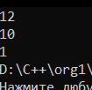 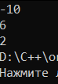 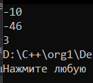 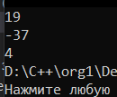

// IF24

#include<iostream>

#include<math.h>

using namespace std;

int main()

{

setlocale(LC_ALL, "Ru");

int x, y = 0;

cin >> x;

if (x > 0)

{

y = 2 * sin(x);

}

else

{

y = 6 - x;

}

cout << y;

}

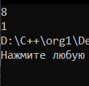 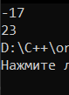

// IF26

#include<iostream>

#include<math.h>

using namespace std;

int main()

{

setlocale(LC_ALL, "Ru");

int x, y = 0;

cin >> x;

if (x <= 0)

{

y = -x;

}

if (0 < x && x < 2)

{

y = pow(x, 2);

}

if (x >= 2)

{

y = 4;

}

cout << y;

}

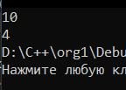 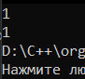 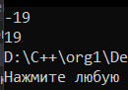

// CASE6

#include<iostream>

using namespace std;

int main()

{

setlocale(LC_ALL, "Ru");

int a, b;

cin >> a >> b;

switch (a)

{

case 1:

cout << (float)b / 10;

break;

case 2:

cout << b * 1000;

break;

case 3:

cout << b;

break;

case 4:

cout << (float)b / 1000;

break;

case 5:

cout << (float)b / 100;

break;

}

}

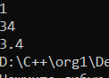 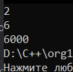 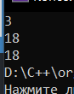 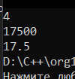 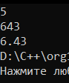

// CASE8

#include<iostream>

using namespace std;

int main()

{

setlocale(LC_ALL, "Ru");

int D, M;

cin >> D >> M;

cout << D - 1 << endl << M;

}

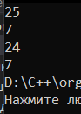

// CASE10

#include<iostream>

using namespace std;

int main()

{

setlocale(LC_ALL, "Ru");

int a;

cin >> a;

switch (a)

{

case 1:

cout << "Запад";

break;

case 0:

cout << "Север";

break;

case -1:

cout << "Восток";

break;

}

}

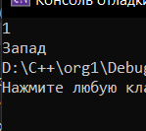 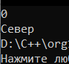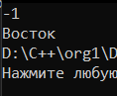

// CASE12

#include<iostream>

#include<math.h>

using namespace std;

int main()

{

setlocale(LC_ALL, "Ru");

int a, R, D, L, S;

cin >> a;

const double P = 3.14;

switch (a)

{

case 1:

cin >> R;

cout << "D = " << 2 * R << endl;

cout << "L = " << 2 * P * R << endl;

cout << "S = " << P * R * R << endl;

break;

case 2:

cin >> D;

cout << "R = " << (float)D / 2 << endl;

cout << "L = " << P * D << endl;

cout << "S = " << P * ((float)D / 2) * ((float)D / 2) << endl;

break;

case 3:

cin >> L;

cout << "R = " << ((float)L / 2) / P << endl;

cout << "D = " << 2 * (((float)L / 2) / P) << endl;

cout << "S = " << P * (((float)L / 2) / P) * (((float)L / 2) / P) << endl;

break;

case 4:

cin >> S;

cout << "R = " << sqrt((float)S / P) << endl;

cout << "D = " << 2 * (sqrt((float)S / P)) << endl;

cout << "L = " << 2 * P * ((float)S / P) << endl;

break;

}

}

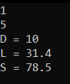 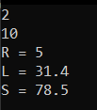 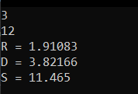 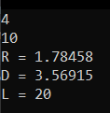

// CASE14

#include<iostream>

#include<math.h>

using namespace std;

int main()

{

setlocale(LC_ALL, "Ru");

int d, a, r1, r2, s;

cin >> d;

switch (d)

{

case 1:

cin >> a;

cout << "R1 = " << a * ((float)sqrt(3) / 6) << endl;

cout << "R2 = " << 2 * (a * ((float)sqrt(3) / 6)) << endl;

cout << "S = " << pow(a, 2) * ((float)sqrt(3) / 4) << endl;

break;

case 2:

cin >> r1;

cout << "A = " << (float)r1 / ((float)sqrt(3) / 6) << endl;

cout << "R2 = " << 2 * r1 << endl;

cout << "S = " << pow((float)r1 / ((float)sqrt(3) / 6), 2) * ((float)sqrt(3) / 4) << endl;

break;

case 3:

cin >> r2;

cout << "A = " << (float)((float)r2 / 2)/ ((float)sqrt(3) / 6) << endl;

cout << "R1 = " << (float)r2 / 2 << endl;

cout << "S = " << pow((float)((float)r2 / 2) / ((float)sqrt(3) / 6), 2) * ((float)sqrt(3) / 4) << endl;

break;

case 4:

cin >> s;

cout << "A = " << sqrt((float)s / ((float)sqrt(3) / 4)) << endl;

cout << "R1 = " << (sqrt((float)s / ((float)sqrt(3) / 4))) * ((float)sqrt(3) / 6) << endl;

cout << "R2 = " << 2 * ((sqrt((float)s / ((float)sqrt(3) / 4))) * ((float)sqrt(3) / 6)) << endl;

break;

}

}

